Chapter 10

Platforms, Network Effects, and Competing in a Winner-Take-All World

10.1 Introduction

Learning Objectives
- Define network effects.
- Recognize products and services that are subject to network effects.
- Understand the factors that add value to products and services that are subject to network effects.
Network effects
Also known as Metcalfe’s Law or network externalities. When the value of a product or service increases as its number of users expands.
are sometimes referred to as “Metcalfe’s Law” or “network externalities.” But don’t let the dull names fool you—this concept is rocket fuel for technology firms. Bill Gates leveraged network effects to turn Windows and Office into virtual monopolies and, in the process, became the wealthiest man in America. Mark Zuckerberg of Facebook; Sergey Brin and Larry Page of Google; Pierre Omidyar of eBay; Kevin Systrom of Instagram; Jack Dorsey, Evan Williams, and Biz Stone of Twitter; Nik Zennström and Janus Friis of Skype; Steve Chen and Chad Hurley of YouTube; Jan Koum and Brian Acton of WhatsApp; Jeff Bezos’s Kindle; Travis Kalanick of Uber; and the Airbnb triumvirate of Brian Chesky, Joe Gebbia, and Nathan Blecharczyk—all these entrepreneurs have built massive user bases by leveraging the concept. And while U.S. firms dominate in creating gargantuan firms fueled by network effects, the phenomenon isn’t limited to the United States. China’s Alibaba; Tencent (with WeChat, QQ, and Qzone); China’s ride-share giant, Didi; and TikTok parent ByteDance have all become multibillion-dollar firms by leveraging the concept. Giant e-commerce marketplace Shopify is Canadian. Skype was started in Sweden. And recently, investors have poured over $60 billion into Indian startups hoping to leverage network effects to build giants in one of the world’s largest and fastest-growing markets. Indian firms hoping for greatness through network effects include Paytm (digital payments), FlipKart (e-commerce), and Swiggy (delivery). When network effects are present, the value of a product or service increases as the number of users grows. Simply, more users = more value. Of course, most products aren’t subject to network effects; you probably don’t care if someone wears the same socks, uses the same pancake syrup, or buys the same trash bags as you. But when network effects are present, they’re among the most important reasons you’ll pick one product or service over another. You may care very much, for example, if others are part of your social network, if your video game console is popular, if the VR (virtual reality) platform you’re considering is likely to be a market leader, if the book you’re about to download will work with your e-Reader, if the car you’re going to buy can be re-juiced using the most charging stations, and if the Wikipedia article you’re referencing has had previous readers. And all those folks who bought HD DVD players, Nook e-readers, Zune music players, or Windows phones sure were bummed when the rest of the world declared Blu-ray, Kindle, iPod, and iOS/Android the market standards. In each of these examples, network effects are at work.
Building a network of users is powerful; building a network of firms that enhance the network’s value, even more so, and that’s the promise of platforms. Platforms
Products and services that allow for the development and integration of software products and other complementary goods, effectively creating an ecosystem of value-added offerings. Windows, iOS, the Kindle, and the standards that allow users to create Facebook apps are all platforms.
create an ecosystem rather than a singular product or service offering. Think of the number of products and services available for iOS (apps, hardware, cars, gym equipment, medical records). Still need convincing? As of this writing, eight of the ten most valuable U.S. firms by market capitalization not only benefit from network effects, but are platform firms (Apple, Microsoft, Alphabet, Amazon, Nvidia, Meta, Tesla, and Visa).

Not That Kind of Network
The term network sometimes stumps people when first learning about network effects. In this context, a network doesn’t refer to the physical wires or wireless systems that connect pieces of electronics. It just refers to a common user base that is able to communicate and share with one another. So Facebook users make up a network. So do the electric car owners and charging stations that use the NACS charging standard, traders who buy and sell stock over the NASDAQ, or the sum total of hardware and outlets that support the BS 1363 electrical plug standard.

Key Takeaway
- Network effects are among the most powerful strategic resources that can be created by technology-based innovation. Many category-dominating organizations and technologies, including Microsoft, Apple, Airbnb, NASDAQ, Kindle, Facebook, and Visa, owe their success to network effects. Network effects are also behind the establishment of most standards, including Blu-ray, Wi-Fi, and Bluetooth.

10.2 Platforms Are Powerful, but Where Does All That Value Come From?

Learning Objectives
- Identify the three primary sources of value for network effects.
- Recognize factors that contribute to the staying power and complementary benefits of a product or service subject to network effects.
- Understand how firms like Microsoft and Apple each benefit from strong network effects.
- Examine Roblox as a platform that has benefited from network effects.
The value derived from network effects comes from three sources: exchange, staying power, and complementary benefits.

Exchange
Instagram for one person isn’t much fun, and the first guy in the world with a fax machine didn’t have much more than a paperweight. But as each new Instagram friend or fax user comes online, a network becomes more valuable because its users can potentially communicate with more people. These examples show the importance of exchange in creating value. Every product or service subject to network effects fosters some kind of exchange. For firms leveraging technology, this might include anything you can represent in the ones and zeros of digital storage, such as messaging, movies, music, money, video games, and computer programs. And just about any standard that allows things to plug into one another, interconnect, or otherwise communicate will live or die based on its ability to snare network effects.

Exercise: Graph It
Some people refer to network effects by the name Metcalfe’s Law. It got this name when, toward the start of the dot-com boom, Bob Metcalfe (the inventor of the Ethernet networking standard) wrote a column in InfoWorld magazine stating that the value of a network equals its number of users squared. What do you think of this formula? Graph the law with the vertical axis labeled “value” and the horizontal axis labeled “users.” Do you think the graph is an accurate representation of what’s happening in network effects? If so, why? If not, what do you think the graph really looks like?

Staying Power
Users don’t want to buy a product or sign up for a service that’s likely to go away, and a number of factors can halt the availability of an effort: A firm could go bankrupt or fail to attract a critical mass of user support, or a rival may successfully invade its market and draw away current customers. Networks with greater numbers of users suggest a stronger staying power
The long-term viability of a product or service.
. The staying power, or long-term viability, of a product or service is particularly important for consumers of technology products. Consider that when someone buys a personal computer and makes a choice of Windows, Mac OS, or Linux, their investment over time usually greatly exceeds the initial price paid for the operating system. A user invests in learning how to use a system, buying and installing software, entering preferences or other data, creating files—all of which means that if a product isn’t supported anymore, much of this investment is lost.
The concept of staying power (and the fear of being stranded in an unsupported product or service) is directly related to switching costs
The cost a consumer incurs when moving from one product to another. It can involve actual money spent (e.g., buying a new product) as well as investments in time, any data loss, and so forth.
(the cost a consumer incurs when moving from one product to another), and switching costs can strengthen the value of network effects as a strategic asset. The higher the value of the user’s overall investment, the more they’re likely to consider the staying power of any offering before choosing to adopt it. Similarly, the more a user has invested in a product, the less likely they are to leave. Early adopters of e-readers that were aware of Barnes & Noble’s struggles likely weighed this when considering the Nook versus Amazon’s thriving and dominant Kindle.
Switching costs also go by other names. You might hear the business press refer to products (particularly websites) as being “sticky” or creating “friction.” Others may refer to the concept of “lock-in.” And the elite Boston Consulting Group is really talking about a firm’s switching costs when it refers to how well a company can create customers who are “barnacles” (that are tightly anchored to the firm) and not “butterflies” (that flutter away to rivals). The more friction available to prevent users from migrating to a rival, the greater the switching costs. And in a competitive market where rivals with new innovations show up all the time, that can be a very good thing!
It is this switching cost that has given our customers the patience to stick with Windows through all our mistakes, our buggy drivers, our high total cost of ownership
An economic measure of the full cost of owning a product (typically computing hardware and/or software). TCO includes direct costs such as purchase price, plus indirect costs such as training, support, and maintenance.
(TCO), our lack of a sexy vision at times, and many other difficulties . . . Customers constantly evaluate other desktop platforms, [but] it would be so much work to move over that they hope we just improve Windows rather than force them to move. . . . In short, without this exclusive franchise [meaning Windows] we would have been dead a long time ago.
—Comments from a Microsoft General Manager in a memo to Bill Gates

Complementary Benefits
Complementary benefits
Products or services that add additional value to the primary product or service that makes up a network.
are those products or services that add additional value to the network. These products might include “how-to” books, software, and feature add-ons, even labor. You’ll find more books about auctioning that focus on eBay, more cameras that upload video to YouTube, and more accountants who know Excel than other rival software. Why? Book authors, camera manufacturers, and accountants invest their time and resources where they’re likely to reach the biggest market and get the greatest benefit. In auctions, video, and spreadsheet software, eBay, YouTube, and Excel each dwarf their respective competition.
Products and services that encourage others to offer complementary goods are sometimes called platforms
Products and services that allow for the development and integration of software products and other complementary goods, effectively creating an ecosystem of value-added offerings. Windows, iOS, the Kindle, and the standards that allow users to create Facebook apps are all platforms.
. Many firms do this by providing APIs
Programming hooks, or guidelines, published by firms that tell other programs how to get a service to perform a task, such as send or receive data. For example, Amazon provides application programming interfaces (APIs) to let developers write their own applications and websites that can send the firm orders.
or application programming interfaces that allow third parties to integrate with their products and services. Allowing other firms to contribute to your platform can be a brilliant strategy because those firms will spend their time and money to enhance your offerings. Consider the billion-dollar hardware ecosystem that Apple has cultivated around iOS products. There are over ninety brands selling some 280 models of speaker systems. Apple has begun to extend iOS into all sorts of products. CarPlay puts Siri on your steering wheel and allows auto manufacturers to integrate phone, maps, messaging, music, and other apps into automobile dashboards. Eighteen auto manufacturers, from Ford to Ferrari, committed to CarPlay at launch, and many more have been added since then. HealthKit allows Apple to use iOS as a platform for exercise and personal health measurement. HomeKit and the Home app allow iOS to control home products, including locks, lighting, security cameras, and thermostats. Today, every major maker of home accessories supports the HomeKit platform. Apple Message has also become a platform, allowing developers to build apps to share cash via a text or jointly order food with friends. Apple’s CloudKit allows developers to plug into Apple’s storage, hopefully creating greater bonds with iOS at the center instead of choosing rival storage platforms from Dropbox, Google, Microsoft, or others. AirPlay links Macs, iOS devices, and AppleTV. Apple Watch is designed as a tool that integrates and extends the iPhone. And Apple hopes to forge a new platform with the launch of its VisionPro—a device that blends augmented reality and virtual reality in what Apple defines as spatial computing. And Apple Pay and Siri make iOS platforms all the more valuable by allowing developers to integrate payments and voice into their apps. Each add-on enhances the value of choosing iOS over rival platforms. Software-based ecosystems can grow very quickly. Less than one year after its introduction, the iOS App Store boasted over fifty thousand applications, collectively downloaded over 1 billion times. Today, well over 2 million iOS apps have been downloaded over 130 billion times, collectively. The App Store ecosystem now generates over $1 trillion in sales, advertising, and other revenue, with the majority of this take going to the firms that participate on the platform. The platform also becomes a launching pad for services businesses. Apple’s collective services businesses—which include Apple Music, Games, Fitness, iCloud, the Apple Card and other financial services, and more—generated over $78 billion in 2023. That’s more than the amount taken in by firms like General Electric, Goldman Sachs, McDonald’s, or Boeing.
These three value-adding sources—exchange, staying power, and complementary benefits—often work together to reinforce one another in a way that makes the network effect even stronger. When users exchange information attract more users, they can also attract firms offering complementary products. When developers of complementary products invest time writing software—and users install, learn, and customize these products—switching costs are created that enhance the staying power of a given network. From a strategist’s perspective this can be great news for dominant firms in markets where network effects exist. The larger your network, the more difficult it becomes for rivals to challenge your leadership position.
Apple Vision Pro Impressions!
Apple introduced its Vision Pro at its World Wide Developer Conference (WWDC) months before the product will ship. It also introduced a set of free tools so that software developers could get to work, adapting their current work to the new platform and creating new experiences. Apple recognizes that a thriving platform will be key to the collective value delivered to justify the Vision Pro’s initially high price. Marques Brownlee was one of the few people given a first-day look at VisionPro and provides a thorough assessment of many of the first-gen product’s features, strengths, and areas that’ll need improvement before VisionPro becomes a mass market success.

Roblox—a $30 Billion Giant Featuring Some Pint-Sized Platform Builders
For those who haven't spent time with elementary and middle school children, the rise of Roblox might have been a surprise. But the firm, founded in 2004, has steadily risen to become a powerhouse in the market of virtual worlds, content creation, and code education, and has ambitions far beyond the exceptionally youthful base that turned it into a $30 billion company.
Often compared to Microsoft-owned Minecraft, Roblox is a virtual world where you get an avatar (and can customize it with some for-fee options), and can do all sorts of things, including: attend a birthday party, raise a pet, visit a theme park, hop in an animated race car, or attend a virtual high school. The firm's platform, Roblox Studio, allows users to create their own games and experiences and share these with others. Quarantine kids who couldn't meet friends in the park or at school flocked to Roblox—via browser, app, or console; and over half the kids in America are citizens of the Roblox world. By year end 2020, just months before the firm's public offering, Roblox had over 150 million members and was averaging over 32 million daily active users
Also known by the acronym DAU, this refers to the number of unique visitors, on average, who use a product or service.
(DAUs), who spent an average of 2.6 hours each day in the Roblox world. Total time on the platform in 2020 totaled over 30.6 billion hours. Roblox was one of those few firms that was actually helped by the pandemic. The end of quarantine has led to an expected downturn in stock, but while the firm has yet to post consistent profits, 2022 revenues climbed to $2.2 billion, and growth in users, revenue, and older demographics are all up, exceeding analyst expectations.
Since creating in the Roblox world often involves learning to code, many parents feel better about Roblox screen time than if their kids were simply smashing bad guys in a standard console video game. Develop something other Roblox users want and you can sell it in Robux, the online currency that players spend real money for. Roblox takes a 30 percent cut of all sales on the platform, but even with that, Roblox is estimated to have shelled out nearly a third of a billion to its mostly young developers in 2020. Like YouTube or App Store success, big bucks through Robux is elusive. Only 1.25 million of the firm's over 8 million active Roblox developers have made any money on the platform, but over 1,250 have made over $10,000, 300 have made over $100,000, and three devs earned over $10 million. Twenty-one-year-old Alex Balfanz earned enough on Roblox to fund his four years at Duke. Developers earned over $620 million collectively on the platform in 2022 alone, and is developing new ways for developers to earn, such as subscriptions.
Figure 10.1 Marketing Spend at IPO
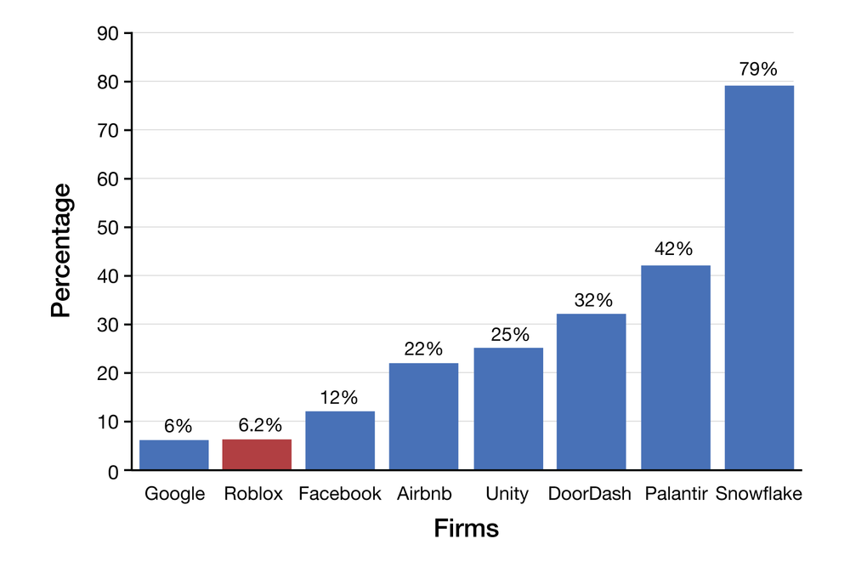
Source: Data from A. Levy, “Coinbase and Roblox Take a Page from Google, Keeping Marketing Costs Way Down ahead of Public Debuts,” CNBC, Feb. 28, 2021. Retrieved from: https://www.cnbc.com/2021/02/28/coinbase-roblox-take-page-from-google-keeping-marketing-costs-down.html.
The virality of Roblox’s young fan base, and the tendency of kids to recruit their friends using word-of-mouth have helped Roblox grow to its current massive size on just a pint-sized ad budget. Customer acquisition costs
The amount of money a firm spends to convince a customer to buy (or in the case of free products, try or use) a product or service.
(CAC) are a metric to pay attention to. CAC is a cost, so firms that can keep CAC low should be able to realize potential profits faster, and at Roblox, those numbers are rock-bottom low. The chart above shows marketing spend as a percentage of revenue by a subset of major public tech firms on the eve of their public offerings. Among big-name tech IPOs, Google is the only big name with a percentage of revenue spent on marketing in the single digits. Even Facebook—a viral champion—came in above 12 percent.
Minecraft has become a darling of early learn-to-code educators, and Roblox, with animations that are more robust than the blocky characters in Microsoft's virtual world, might have even more educational headroom to grow. CEO Dave Baszucki envisions educational experiences such as virtual physics worlds, where teachers can lead students on Roblox-world field trips where they experiment and try out learning concepts. Creating a platform for kids is wrought with dangers, and many firms have suffered from a mix of missteps and perils that range from overzealous data collection to toxic communities to prowling pedophiles. Roblox recognizes this, and over its long history it's developed a playbook that keeps the trust of parents and builds a supportive culture. The company employs a trust and safety team of over 2,300; leads with a parents’ page describing the platform, policies, and safety measures; and co-founder and CEO Baszucki often states the goal of the firm is to be “the world’s safest and most civil society.”
The firm's youngster focus provided a great base, but Roblox has already begun efforts to appeal to older crowds, as well. Keeping things safe for kids may get more challenging as the platform creates experiences that appeal to an older, broader user base. Events that move beyond the middle and grade school crowd include an online concert featuring crossover rapper Lil Nas X, who brought his “Old Town Road” to Roblox in a virtual performance that attracted over 30 million visits (watch the “Lil Nas X Full Roblox Concert” video). Many firms also see Roblox as an important test-bed for the metaverse
Immersive digital worlds. The term metaverse was coined by science fiction writer Neal Stephenson in his 1992 novel Snow Crash. The term has become so ubiquitous that it inspired Facebook to rebrand itself as Meta.
, and brands launching Roblox experiences are a diverse group that includes the NHL and clothing retailer H&M. Look for more innovative efforts as the company's massive recent capital raises fuel even more R&D (the company spent $201.4 million in research and development in 2020, up 88 percent from the prior year). With Apple and Meta among the firms announcing advanced AR and VR products, Roblox may be positioned to leverage its early lead and experience to become a leading player on new platforms.
Virtual worlds rise and fall. Chances are, many of the readers might never have heard of Second Life, a virtual world that attracted millions of users in the early '00s and at one time was worthy of business press cover stories and where the band U2 once held a concert. The Sims, Animal Crossing, and Minecraft have offered varying degrees of staying power in the space. But Roblox is, so far, the most valuable of the bunch.
How Roblox Became a $30 Billion Business
A video showcasing how Roblox became such a massive gaming staple, and its growth during the COVID-19 pandemic of 2020 and 2021.

Key Takeaways
- Products and services subject to network effects get their value from exchange, perceived staying power, and complementary products and services. Tech firms and services that gain the lead in these categories often dominate all rivals.
- Many firms attempt to enhance their network effects by creating a platform for the development of third-party products and services that enhance the primary offering.
- Roblox grew into a $30 billion firm by creating a platform for third-party content creators. Virality helped the company expand its user based via word-of-mouth, keeping customer acquisition costs low. By sharing 70 percent of revenue earned by platform content developers, Roblox harnesses the creativity of its user base and paid out over $320 billion on the eve of its IPO.

10.3 One-Sided or Two-Sided Markets?

Learning Objectives
- Recognize and distinguish between one-sided and two-sided markets.
- Understand same-side and cross-side exchange benefits.
- Explore key concepts by examining the standards for electric vehicle (EV) charging.

Understanding Network Structure
To understand the key sources of network value, it’s important to recognize the structure of the network. Some networks derive most of their value from a single class of users. An example of this kind of network is messaging. While you might have different messaging apps for different purposes (Snapchat for disposable posts, Instagram for photos), you pretty much choose a tool based on how many of your contacts you can reach. Economists would call messaging a one-sided market
A market that derives most of its value from a single class of users (e.g., instant messaging).
(a market that derives most of its value from a single class of users), and the network effects derived from users attracting more users as being same-side exchange benefits
Benefits derived by interaction among members of a single class of participant (e.g., the exchange value when increasing numbers of IM users gain the ability to message each other).
(benefits derived by interaction among members of a single class of participant).
But some markets comprise two distinct categories of network participants. Consider video games. People buy a video game console largely based on the number of really great games available for the system. Software developers write games based on their ability to reach the greatest number of paying customers, so they’re most likely to write for the most popular consoles first. Economists would call this kind of network a two-sided market
Network market that comprises two distinct categories of participant, both of which are needed to deliver value for the network to work (e.g., video game console owners and developers of video games).
(a network markets that comprises two distinct categories of participant, both of which are needed to deliver value for the network to work). When an increase in the number of users on one side of the market (console owners, for example) creates a rise in the other side (software developers), that’s called a cross-side exchange benefit
When an increase in the number of users on one side of the market (console owners, for example) creates a rise in the other side (software developers).
.

The Positive Feedback Loop of Network Effects: One-Sided, Two-Sided, and Sometimes a Bit of Both
Messaging is considered a one-sided market (or one-sided network), where the value-creating, positive-feedback loop of network effects comes mostly from same-side benefits from a single group (messaging members who attract other members who want to communicate with them). Mobile payment efforts like Square, Apple Pay, and Android Pay, however, are considered to be two-sided markets, where significant benefits come from two distinct classes of users that add value by attracting each other. In the case of mobile payments, the more people who use a given payment platform, the more attractive that platform will be to storefronts and other businesses, and if more businesses accept these forms of mobile payment, then this in turn should attract more end consumers (and so on). Jump-starting a two-sided network can be tricky. Google and Apple use their mobile operating systems to embed their payment apps in millions of hardware products. Google leveraged its presence on Android and its ad relationship with many retailers to jump-start Google Pay. iTunes and the App Store helped Apple have over 800 million credit cards on file at the launch of Apple Pay for iOS. Firms need a strong incentive for users to download and set up payments. Starbucks built a wildly successful payments app by offering rewards for frequent customer purchases. However, Square’s Cash payment app struggled when customers saw little incentive to install an app when cash and credit worked fine and using the app offered no incentive over alternatives. It wasn’t until Square (note, the parent firm is now known as Block, Inc.) offered features that customers valued and rivals didn’t offer—such as accepting Bitcoin and direct deposits, that Square Cash (often referred to as the Cash App) began to gain traction (Square took in $4.57 billion in Bitcoin-related revenue in 2020).
It’s also possible that a network may have both same-side and cross-side benefits. Microsoft’s Xbox benefits from cross-side benefits in that more users of that console attract more developers writing more software titles and vice versa. However, the Xbox Live network that allows users to play against each other has same-side benefits. If your buddies use Xbox Live and you want to play against them, you’re more likely to buy an Xbox. Apple also created a two-sided game in messaging when it turned iOS messaging into a platform, allowing app developers to add all sorts of new capabilities, from custom emojis and animations to collaborative apps shared via what used to be simple text messaging.

Electric Vehicle Charging Standards: Everyone versus Tesla—and It Looks Like Tesla Won
The widespread adoption of electric vehicles (EV) is also a two-sided market. Customers don't just buy a car; they also need spots to go for a recharge. While initial adopters of EVs were wealthier families who already had a gas-powered vehicle, mainstream EV use among single-car owners won't happen until those users can feel comfortable that their only ride can always be charged and ready to go. Yet in the early days of North American EV competition, the two main standards for vehicle charging were incompatible: Tesla's standard—NACS (North American Charging Standard), and the standard used by virtually all other EVs sold in North America, CCS (the Combined Charging System). CCS was developed by CharIN, a consortium of European automakers. By inviting everyone to participate in its creation, it looked like this standard had an advantage. The U.S. government even lobbied for CCS as the standard, and the Bipartisan Infrastructure Law required CCS plugs at charging stations that received federal funding. But today it seems, at least in North America, that NACS is the winner. How come?
Tesla had a huge head start. By the end of 2022, Teslas represented about two-thirds of the EVs sold in the United States. This user base, coupled with an aggressive rollout by Tesla of the firm's charging stations, led to the firm’s having far more total charging ports (19,463 by 2023) in North America than combined rival standards (6,930 for CCS, alone). This gave Tesla’s standard a lead in both sides of that two-sided market—car owners as well as the places where owners could charge up. Tesla also chose prime locations for its superchargers—placing them near major roadways with nearby amenities (malls, grocery stores, and restaurants). Tesla sites have at least eight charging connectors to minimize frustration from a lack of availability at a given location. Tesla stations are also brightly lit and well maintained. Tesla has also built its cars and stations as a closed system of exceptional convenience. Drivers simply pull into a Supercharger and plug in. The system handles customer billing automatically. By contrast, CCS stations have fewer total ports and ports per station, and fail more often. Remarkably, despite the fact that Tesla's technology was older and CCS brought together a consortium of minds across multiple firms, most in the industry considered Tesla's standard to be superior. NACS plugs are also half the size and twice as powerful as CCS equipment. NACS ports are solid state—no moving parts means the connectors are less prone to breaking. Then in November 2022, Tesla opened its once-proprietary standard, allowing any firm to use its patented designs free of charge. By mid-2023 the market was tipping. Kentucky required charging companies to include NACS connectors on in-state federally funded contracts, and Texas and Washington announced similar efforts to back NACS. Around this time, Ford, Nissan, GM, Mercedes-Benz, EV industrial van firm Rivian, and Volvo all announced they will be supporting NACS. The ChargePoint and Electrify America charging networks also both announced support for the Tesla standard. Many automakers cited the strength of the NACS charging network, and NACS technology, as a major motivation to choose NACS. While the world still has a long way to go before EVs outsell gas-powered vehicles, a common charging standard should speed the creation of an infrastructure that encourages more wide-spread use.
The Incredible Logistics of Tesla's Supercharging Network
Curious about EV charging standards and why it seems Tesla’s superior technology has won? Here’s an overview of various technologies and issues involved.
Transcript

Key Takeaways
- In one-sided markets, users gain benefits from interacting with a similar category of users (think messaging apps, where everyone can send and receive messages to and from one another).
- In two-sided markets, users gain benefits from interacting with a separate, complementary class of users (e.g., in the mobile payment business, payment app–wielding consumers are attracted to a platform because there are more merchants offering convenient payment, while merchants are attracted to a payment system that others will actually use and that yields clear benefits over cash).

10.4 How Are These Markets Different?

Learning Objectives
- Understand how competition in markets where network effects are present differs from competition in traditional markets.
- Understand the reasons why it is so difficult for late-moving, incompatible rivals to compete in markets where a dominant, proprietary standard is present.
When network effects play a starring role, competition in an industry can be fundamentally different than in conventional, non-network industries.
First, network markets experience early, fierce competition. The positive-feedback loop inherent in network effects—where the biggest networks become even bigger—causes this. Firms are very aggressive in the early stages of these industries because once a leader becomes clear, bandwagons form, and new adopters begin to overwhelmingly favor the leading product over rivals, tipping the market in favor of one dominant firm or standard. This tipping can be remarkably swift. Once the majority of major studios and retailers began to back Blu-ray over HD DVD, the latter effort folded within weeks. As was shown in the prior section, we may have seen a similar “tipping point” reached in the competing standards for EV charging.
These markets are also often winner-take-all or winner-take-most, exhibiting monopolistic tendencies where one firm dominates all rivals. Look at all of the examples listed so far—in nearly every case the dominant player has a market share well ahead of all competitors. When, during the U.S. Microsoft antitrust trial, Judge Thomas Penfield Jackson declared Microsoft to be a monopoly
A market where there are many buyers but only one dominant seller.
(a market where there are many buyers but only one dominant seller), the collective response should have been “of course.” Why? The natural state of markets where strong network effects are present (and this includes operating systems and Office software) is for there to be one major player. Since bigger networks offer more value, they can charge customers more. Firms with a commanding network effects advantage may also enjoy substantial bargaining power over partners. For example, at the height of iTunes success, Apple controlled over 75 percent of digital music sales and for years was able to dictate song pricing despite the tremendous protests of the record labels. In fact, Apple’s stranglehold was so strong that it leveraged bargaining power even though the “Big Four” record labels (Universal, Sony, EMI, and Warner) were themselves an oligopoly
A market dominated by a small number of powerful sellers.
(a market dominated by a small number of powerful sellers) that together provide over 85 percent of music sold in the United States.

Are These Firms Too Big? Citizenship and Management in the Age of Giants
If you are an entrepreneur whose firm has grown so large that it is now the subject of an antitrust investigation, some may say “Congratulations, you've won.” Very few firms grow to dominate their sectors with such a hammerlock that competition seems impossible. Yet today we see an increasing call to reexamine capitalism in the tech era. European and American trust busters are pursuing Amazon, Apple, Meta, and Alphabet’s Google, to varying degrees. And even China—not known for taking an anti-monopoly stance against homegrown firms—has launched an investigation into Alibaba’s influence in its domestic markets. But some regulatory efforts seem comically out of touch—among these Australia’s attempt to require Facebook and Google to pay news organizations any time someone shared a link. Should Facebook be broken up when it wields so much influence it is a single source for the nefarious to attack democracies? Should Amazon be broken up when it has grown so large that it is effectively the only game in town for the online purchase of many product categories? And is there some midpoint between leaving these firms alone and breaking them up or introducing arguably stifling regulation?
If you are a manager at a dominant firm, you'll have to realize that every misstep strengthens the magnet of public criticism and pulls in the proverbial iron bits that form increased regulation. While startups can get away with a freewheeling “move fast, break things” attitude and chalk missteps up to essential entrepreneurial experimentalism, large public companies attract legal attention and have a responsibility to shareholders, employees, and vast customer bases, as well. A misstep can repel customers, and potential employees, and bring down a regulatory hammer that could derail the kind of earlier growth giants once enjoyed.
One camp argues that technology, infrastructure, and economics have created the capitalism on steroids that has released monopolistic monsters. The influence of Apple, Google, Meta’s platforms (Facebook, Instagram, WhatsApp), and Amazon as vehicles for communication, information seeking, and purchasing is unprecedented. And along with the power and wealth of these firms is the potential to seek influence through lobbying, advertising, and other efforts. Amazon has become such a lightning rod that it has been criticized by both sides of the aisle, from Elizabeth Warren to former President Donald Trump, all while it remains a first choice for millions of their constituents.
Others point out that the creative destruction, a term coined by early twentieth-century economist Joseph Schumpeter, has always been a tenet of capitalism: It's not firms that compete doing the same thing as a dominant firm that will unseat it, it is the innovator that offers a fundamentally new product or new innovation delivered in such a way that marks a decisive quality or cost break from previous industrial output. Even firms that have seemed to dominate markets with tech products and standards—IBM, Kodak, Apple with iTunes, Microsoft with Internet Explorer—in ways that have raised antitrust concerns in the past, have been displaced not by government action, but by nimble competitors and shortsighted managers. Some even wonder if the rise of OpenAI may be another example of this, offering a service that may challenge Google’s supremacy in search, although others note that at least early-on, Google-rival Bing hasn’t seen any appreciable gain since incorporating ChatGPT into its results.
The vague idea of a “breakup” of a firm like Facebook that relies heavily on network effects is challenging to consider when the natural state of such firms is for there to be a dominant player. What does a breakup mean? A requirement to use public and open standards (e.g., opening the Kindle format might help other booksellers)? A requirement to share infrastructure (e.g., should local cable monopolies be required to rent infrastructure access to competing rivals)? Turning the dominant platform into a public utility? And sometimes a solution might unleash unintended negative outcomes. Apple’s App Store is more tightly controlled than most rivals and many developers have grumbled at Apple’s stringent app approval process, however Apple’s control allows it to apply such safety standards and is also seen as a key reason why iOS devices have relatively few security and scam incidents. Will iOS app stores without Apple’s oversight lead to more security risks?
Your goal as a citizen will be to consider if and when capitalism needs help in guiding a harmful invisible hand, but your role as a manager is to pilot a firm to new markets using tools for dominance and disruption, while also stewarding a firm's accrual of power in responsible and ethical ways. The wise manager won’t fall into a trap of blindly embracing a political philosophy, but will instead work hard to identify the concerns and merits of the scorn and praise foisted on the giants and use this to build a firm that is a paragon of success not just financially, but also in its concern for the customers and society that it serves.
Finally, it’s important to note that the best product or service doesn’t always win. PlayStation 2 dominated the original Xbox in a prior generation’s game console war, despite the fact that nearly every review claimed the Xbox was hands-down a technically superior machine. Why were users willing to choose an inferior product (PS2) over a superior one (Xbox)? The power of network effects! PS2 had more users, which attracted more developers offering more games.
Figure 10.2 Battling a Leader with Network Effects
A new rival facing a strong, incompatible incumbent can't just offer a superior product—the upstart must have an overwhelming additional value that exceeds the benefit of exchange, switching costs, and complementary products, as well.
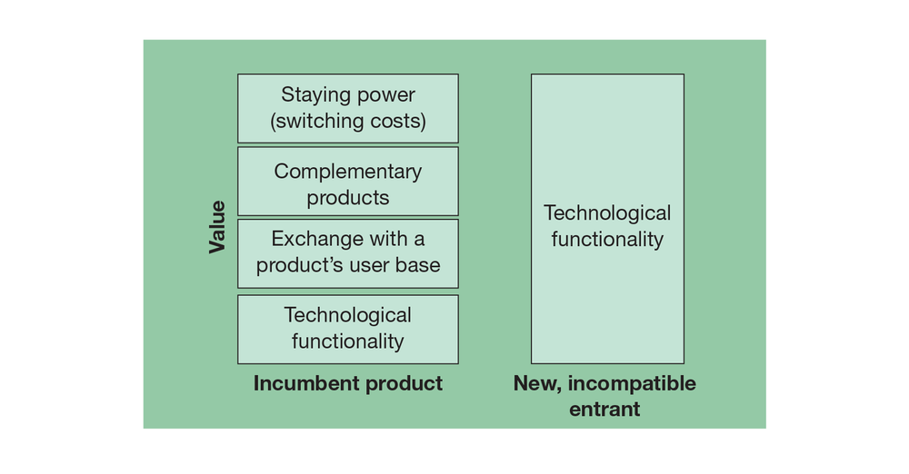
Source: John Gallaugher
Show long description
This last note is a critical point to any newcomer wishing to attack an established rival. Winning customers away from a dominant player in a network industry isn’t as easy as offering a product or service that is better. Any product that is incompatible with the dominant network has to exceed the value of the technical features of the leading player, plus (since the newcomer likely starts without any users or third-party product complements) the value of the incumbent’s exchange, switching cost, and complementary product benefit (refer to Figure 10.2). And the incumbent must not be able to easily copy any of the newcomer’s valuable new innovations; otherwise, the dominant firm will quickly match any valuable improvements made by rivals. As such, technological leapfrogging
Competing by offering a new technology that is so superior to existing offerings that the value overcomes the total resistance that older technologies might enjoy via exchange, switching cost, and complementary benefits.
, or competing by offering a superior generation of technology, can be really tough.

Is This Good for Innovation?
Critics of firms that leverage proprietary standards for market dominance often complain that network effects are bad for innovation. But this statement isn’t entirely true. While network effects limit competition against the dominant standard, innovation within a standard may actually blossom. Consider Windows. Microsoft has a huge advantage in the desktop operating system market, so few rivals try to compete with it. Apple’s Mac OS and the open source Linux operating system are the firm’s only credible rivals, and both have tiny market shares. But the dominance of Windows is a magnet for developers to innovate within the standard. Programmers with novel ideas are willing to make the investment in learning to write software for Windows because they’re sure that a Windows version can be used by the overwhelming majority of computer users.
By contrast, look at the mess we initially had in the mobile phone market. With so many different handsets containing differing computing hardware, offering different screen sizes, running different software, having different key layouts, and working on different carrier networks, writing a game that’s accessible by the majority of users is nearly impossible. Glu Mobile, a maker of online games, launched fifty-six reengineered builds of Monopoly to satisfy the diverse requirements of just one telecom carrier. As a result, entrepreneurs with great software ideas for the mobile market were deterred because writing, marketing, and maintaining multiple product versions is both costly and risky. It wasn’t until Apple’s iPhone arrived, offering developers both a huge market and a consistent set of development standards, that third-party software development for mobile phones really took off. The fact that there are many different Android devices with different hardware specs running different versions of Google’s mobile operating system also creates a challenge for developers. Hong Kong mobile app developer Animoca does quality assurance testing with about 400 Android devices on every app the firm offers.
Figure 10.3 Innovation in Fractured Standards
Because Android runs on so many different devices using various versions of the OS, game developers like Hong Kong-based Animoca test each product released on as many as 400 devices.
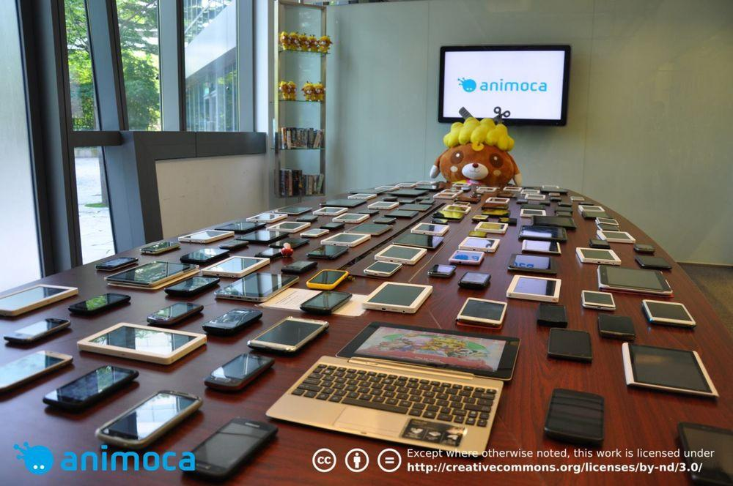
Source: TechCrunch, http://techcrunch.com/2012/05/11/this-is-what-developing-forandroid- looks-like/; Available under CC BY-ND 3.0 DEED, https://creativecommons.org/licenses/by-nd/3.0/.

Key Takeaways
- Unseating a firm that dominates with network effects can be extremely difficult, especially if the newcomer is not compatible with the established leader. Newcomers will find their technology will need to be so good that it must leapfrog not only the value of the established firm’s tech, but also the perceived stability of the dominant firm, the exchange benefits provided by the existing user base, and the benefits from any product complements. For evidence, just look at how difficult it’s been for rivals to unseat the dominance of Windows.
- Because of this, network effects might limit the number of rivals that challenge a dominant firm. But the establishment of a dominant standard may actually encourage innovation within the standard, since firms producing complements for the leader have faith the leader will have staying power in the market.

10.5 Competing When Network Effects Matter

Learning Objectives
- Plot strategies for competing in markets where network effects are present, both from the perspective of the incumbent firm and the new market entrant.
- Give examples of how firms have leveraged these strategies to compete effectively.
Why do you care whether networks are one-sided, two-sided, or some sort of hybrid? Well, when crafting your plan for market dominance, it’s critical to know if network effects exist, how strong they might be, where they come from, and how they might be harnessed to your benefit. Here’s a quick rundown of the tools at your disposal when competing in the presence of network effects.

Strategies for Competing in Markets with Network Effects (Examples in Parentheses)
- Move early (Yahoo! auctions in Japan, Amazon versus Microsoft in cloud computing, Microsoft’s OpenAI investment in generative AI).
- Subsidize product adoption (PayPal, Zoom). Freemium and throttled or limited-access trials can also be considered a form of subsidy since products and services are temporarily offered for free (e.g., limited access to paywall sites, throttled access to ChatGPT).
- Leverage viral promotion (Uber, TikTok, Shein, Temu).
- Expand by redefining the market to bring in new categories of users (Nintendo Wii, Cash App’s embrace of crypto, Nvidia in AI) or through convergence (iPhone).
- Form alliances and partnerships (NYCE versus Citibank, Didi/Ola/GrabTaxi/Lyft global ride-sharing alliance versus Uber).
- Establish distribution channels (Java with Netscape; Microsoft bundling Media Player with Windows; Apple embedding Apple Music in all Macs and iOS devices).
- Seed the market with complements (Blu-ray, Nintendo, ThredUp).
- Encourage the development of complementary goods—this can include offering resources, subsidies, reduced fees, market research, development kits, and training (Oculus and Amazon Echo developer funds, Apple Swift Playgrounds).
- Maintain backward compatibility (Apple’s Mac OS X Rosetta 2 translation software for moving from Intel to MXCHIPs, Samsung Pay using existing mag-stripe standards).
- For rivals, be compatible with larger networks (Samsung Pay’s compatibility with magstripe credit card standards).
- For incumbents, constantly innovate to create a moving target and block rival efforts to access your network (Apple’s efforts to block access to its own systems).
- For large firms with well-known followers, make preannouncements (Microsoft, Apple).

Move Early
In the world of network effects, moving early is a biggie. Being first allows your firm to start the network effects snowball rolling in your direction. In Japan, worldwide auction leader eBay showed up just five months after Yahoo! launched its Japanese auction service. But eBay was never able to mount a credible threat and ended up pulling out of the market. Being just five months late cost eBay billions in lost sales, and the firm eventually retreated, acknowledging it could never unseat Yahoo!’s network effects lead.
Another key lesson from the loss of eBay Japan? Exchange depends on the ability to communicate! eBay’s huge network effects in the United States and elsewhere didn’t translate to Japan because most Japanese aren’t comfortable with English, and most English speakers don’t know Japanese. The language barrier made Japan a “greenfield” market with no dominant player, and Yahoo!’s early move provided the catalyst for victory.
Timing is critical in business-to-business markets, too. Amazon’s AWS led Microsoft in cloud computing by four years, Google by at least two (more in other in subcategories). In that time, AWS gained market share and lock-in, had a host of third-party firms create products and services that worked with AWS, and in the hot market for cloud computing skills, software developers chose to learn AWS because it was first the only, and now remains the biggest, player around. Microsoft’s $13 billion investment in OpenAI, giving it exclusive access to many of the firm’s technologies and which it has integrated into not only cloud offerings, but also Windows, Office, and other products, may be one way that Microsoft is trying to recapture a lead in an emerging and critical technology. However, as cited in the earlier section, when a giant acquires a near-controlling stake in a potentially critical emerging technology, governments may be concerned, and the United Kingdom and the United States have begun to further explore the investment’s implications.

What If Microsoft Threw a Party and No One Showed Up?
Microsoft launched the Zune media player with features that should be subject to network effects—the ability to share photos and music by wirelessly “squirting” content to other Zune users. The firm even promoted Zune with the tagline “Welcome to the Social.” The problem was the Zune Social was a party no one wanted to attend. The late-arriving Zune garnered a market share of just 3 percent, and users remained hard-pressed to find buddies with whom to leverage these neat social features. A cool idea does not automatically make a network effect happen.

Subsidize Adoption
Starting a network effect can be tough—there’s little incentive to join a network if there’s no one in the system to communicate with. In one admittedly risky strategy, firms may offer to subsidize initial adoption in hopes that network effects might kick in shortly after. Subsidies to adopters might include a price reduction, rebate, or other giveaways. PayPal, a service that allows users to pay one another over the Internet using credit cards, gave users a modest rebate as a sign-up incentive to encourage adoption of its new effort (in one early promotion, users got back $15 when spending their first $30). This brief subsidy paid to early adopters paid off handsomely. eBay later tried to enter the market with a rival effort, but as a late mover its effort was never able to overcome PayPal’s momentum. PayPal was eventually purchased by eBay for $1.5 billion, and spun out of eBay at a $45 billion valuation.
Figure 10.4 Sign-up Incentives Are Subsidies for Growing a Market
Two-sided markets offering subsidies that encourage users to sign up. These companies hope that more users will allow them to attract more paying partners. Groupon, Upromise, and SwagBucks are all two-sided markets that attract paying firms to reach more customers.
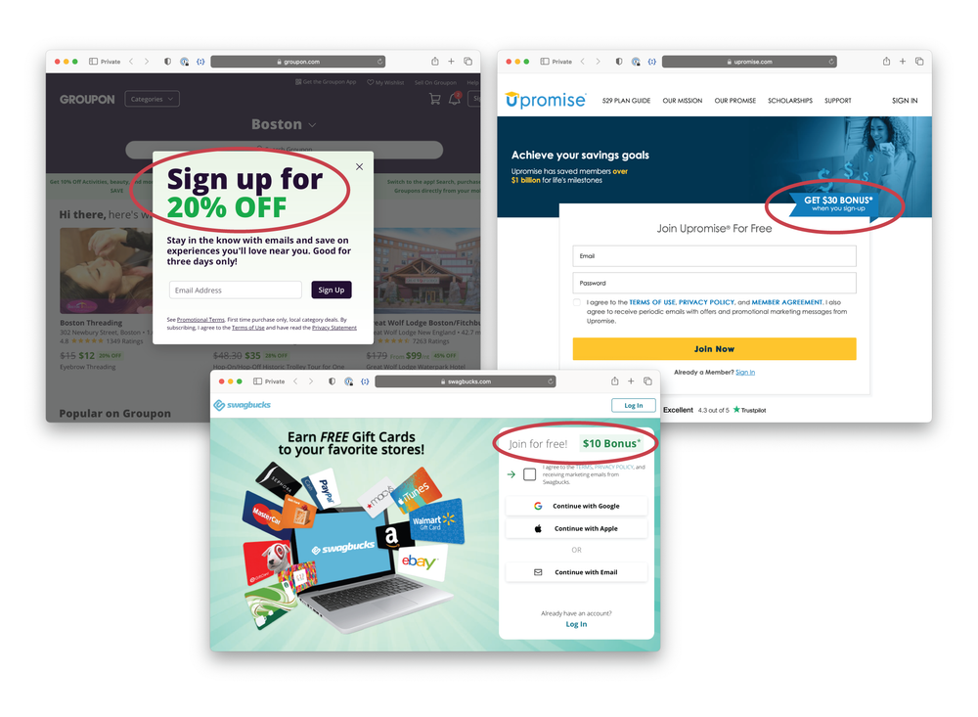
Sources: John Gallaugher; Groupon.com; Upromise.com; SwagBucks.com
Incentives for signing up for a service are quite common. The images in Figure 10.4 show three two-sided networks, all of which offer some sort of firm-provided subsidy for signing up. Groupon is a deals site, Upromise offers cash back for college when shopping with its retail partners, and SwagBucks offers users money and prizes for completing surveys or watching videos. In each case, the network is trying to attract paying partners and the firm can only do this if they have a sufficient number of customers using the service. The more Groupon users, the more likely firms will offer deals through the service; more Upromise users will attract more firms willing to pay Upromise to reach the service's customers; and SwagBucks will attract more firms willing to pay to get their surveys or videos in front of users if there are more users to reach. Groupon will offer 20 percent off if you sign up via e-mail so it can regularly reach you, Upromise offers $30 just for signing up, and SwagBucks offers a $10 signup bonus.
A free product offered via the so-called freemium model is also a type of subsidy. Free Roblox brings newcomers into the platform, turning many into paying customers or content creators—fueling both sides of the two-sided network. The free version of Zoom offers all of the features of the for-fee product, with the only major difference a removal of the forty-minute meeting cap. Subsidies also helped Zoom grow during the pandemic. When the firm offered its video meeting software for free to K–12 schools, demands on infrastructure, support staff, and other resources were pushed to capacity. But parent familiarity with Zoom helped drive awareness that spurred demand for corporate offerings.
Another type of subsidy is offering free or limited access. While a firm doesn’t charge for initial access, it may be throttled or cut off after a certain usage amount. This can be considered a subsidy in that a product or service is being given away; however, the goal of this is to eventually convert the free user into a paying customer. You’ve undoubtedly encountered this online when you’ve visited news sites that may offer a certain number of free articles until a paywall is raised, or via generative AI products like ChatGPT that throttle use by offering only a certain amount of access for free, but more access to paying customers. While freemium and free/limited access aren’t as extreme as subsidizing markets through free or below-cost goods, these techniques can also be used to spur product adoption, and if competitors arise, firms can become more aggressive with these subsidies as well (e.g., more freebies, less throttling).

When Even Free Isn’t Good Enough
Subsidizing adoption after a rival has achieved dominance can be an uphill battle, and sometimes even offering a service for free isn’t enough to combat the dominant firm. When Yahoo! introduced a U.S. auction service to compete with eBay, it initially didn’t charge sellers at all (sellers typically pay eBay a small percentage of each completed auction). The hope was that with the elimination of seller fees, enough sellers would jump from eBay to Yahoo! and help the late mover catch up in the network effect game.
But eBay sellers were reluctant to leave for two reasons. First, there weren’t enough buyers on Yahoo! to match the high bids they earned on much-larger eBay. Some savvy sellers played an arbitrage game where they’d buy items on Yahoo!’s auction service at lower prices and resell them on eBay, where more users bid prices higher.
Second, any established seller leaving eBay would give up their valuable “seller ratings,” and would need to build their Yahoo! reputation from scratch. Seller ratings represent a critical switching cost, as many users view a high rating as a method for reducing the risk of getting scammed or receiving lower-quality goods.
Auctions work best for differentiated goods. While Amazon has had some success in peeling away eBay sellers who provide commodity products (a real danger as eBay increasingly relies on fixed-price sales), eBay’s dominant share of the online auction market still towers over all rivals. While there’s no magic in the servers used to create eBay, the early use of technology allowed the firm to create both network effects and switching costs—a dual strategic advantage that has given it a multibillion-dollar hammerlock on auctions even as others have attempted to mimic its service and undercut its pricing model.

Leverage Viral Promotion
Since all products and services foster some sort of exchange, it’s often possible to leverage a firm’s customers to promote the product or service. Chances are you were recruited to your most popular social media sites, not because you saw an advertisement, but because a friend invited you. Instagram, TikTok, and mobile app integration with a phone’s address book all act as a catalyst for friends to share deals, spread a good word, sign up for services, and load applications.
Viral promotions are also often linked to subsidies (e.g., recruit a new customer and you both get money to spend), but they can also provide the additional benefit of leveraging a trusted friend to overcome adoption inertia. Sharing economy firms Uber and Airbnb have both used these kinds of incentives as trust proxies, or what is sometimes referred to as social proof
The positive influence created when someone finds out that others are doing something.
. When a friend sends an invite to a service where users may otherwise have trust concerns (e.g., Uber and stepping into a car driven by a stranger, staying in someone’s home through Airbnb), an endorsement by a friend can ease concerns. Airbnb saw bookings increase as much as 25 percent in markets after offering friend referral incentives, and the firm says patrons referred by friends are more likely to revisit the site and book future trips, and they are much more likely to send referrals themselves.
Figure 10.5 Shein and Temu Viral Promotions
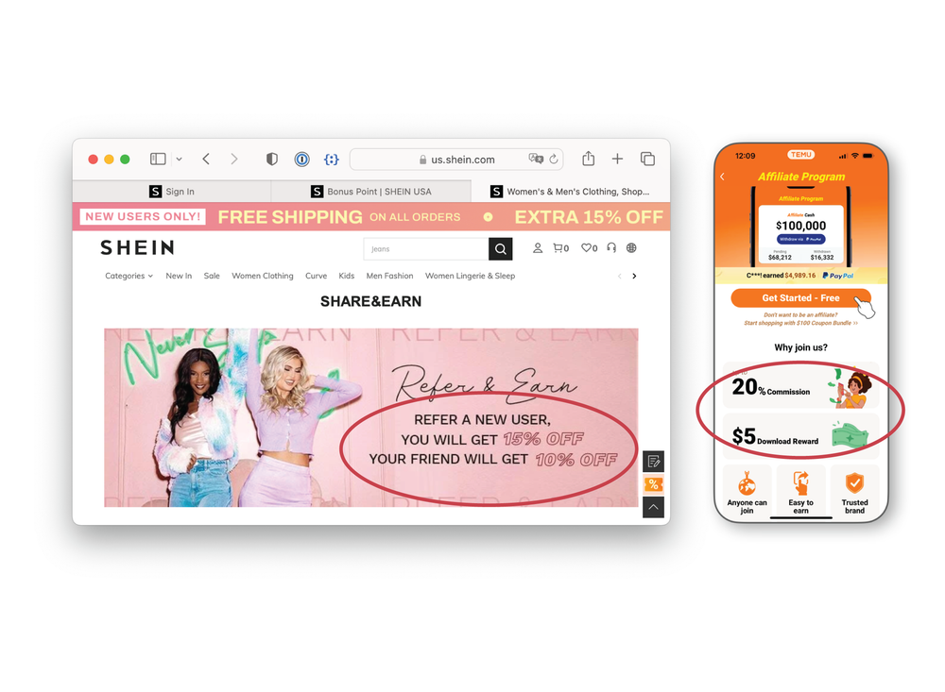
Sources: John Gallaugher; Shein.com; Temu.com
Shopping sites Shein and Temu have also leveraged viral promotion to rapidly expand their brands. Without a recommendation from a friend, these websites might seem like sketchy money-stealers—after all, their prices seem too good to be true. But once a friend recommends the site and verifies they’ve bought and received goods with no scam, you may be prompted to try things out. The Shein and Temu images in Figure 10.5 also show how viral promotion can be leveraged with subsidies. Recommend a friend and Shein will offer both you and your friend an additional discount. Temu will give you a $5 bonus for each referral that results in an app download, and will offer you a 20 percent commission. As of this writing, the Temu app is ranked the most popular shopping app in the United States, while the Shein app also outranks Amazon’s app store downloads in dozens of markets worldwide. It’s important to frame this within the context of what these companies are trying to do. More customers using each site should attract more sellers and vice versa, helping strengthen the network effect and value of these services as e-commerce platforms.

Expand by Redefining the Market
If a big market attracts more users (and in two-sided markets, more complements), why not redefine the space to bring in more users? When Square launched its Cash App, it was far behind PayPal and Venmo, and lacked a built-in distribution network from hardware that Google and Apple enjoyed. But when Square embraced Bitcoin (the firm has even rebranded itself as Block, Inc, a nod to blockchain), a neglected market became a revenue engine and a catalyst that fueled adoption. The Cash App seemingly came out of nowhere to become a major player in online transactions, with Bitcoin powering the way. The firm did $4.57 billion in Bitcoin-related revenue in 2020, up nearly 800 percent over the prior year. By Q4, the Cash App was driving nearly half the firm’s profits. Although it is noted that enabling Bitcoin transactions is a market-creator, but owning Bitcoin, which Block has also begun to do, could prove risky.

Seeking the Blue Ocean? Better Think Strategically
Nintendo did this when launching the Wii. While Sony and Microsoft focused on the graphics and raw processing power favored by hard-core male gamers, Nintendo chose to develop a machine to appeal to families, women, and age groups that normally shunned alien shoot-’em-ups. By going after a bigger, redefined market, Nintendo was able to rack up sales that exceeded those of the Xbox 360, even though it followed the system by twelve months.
Reggie Fils-Aimé, the president of Nintendo of America, has described the Wii strategy as a blue ocean effort. The concept of blue ocean strategy
An approach where firms seek to create and compete in uncontested “blue ocean” market spaces, rather than competing in spaces and ways that have attracted many similar rivals.
was popularized by European Institute of Business Administration (INSEAD) professors W. Chan Kim and Renée Mauborgne (authors of a book with the same title). The idea—instead of competing in blood-red waters where the sharks of highly competitive firms vie for every available market scrap, firms should seek the blue waters of uncontested, new market spaces.
For Nintendo, the granny gamers, moms, and party-goers who flocked to the Wii represented an undiscovered feast in the blue ocean. Talk about new markets! Consider that the bestselling video game following the Wii’s breakout launch was Wii Fit—a genre-busting title that comes with a scale so you can weigh yourself each time you play. That’s a far cry from Grand Theft Auto IV, the title ranking fifth behind four Wii-only exclusives.
Many more examples exist of firms that have found markets where none previously existed. Nvidia discovered a whole new segment of server farm users eager to be served by chips that worked well with massively parallel computing. Uber found customers for ride share that would never otherwise consider calling a cab. Salesforce.com pretty much created the category of software known as Customer Relationship Management (CRM) when it found enterprise customers had a need to track and manage customer interactions. And former students at my university that had no prior experience in the motion picture industry saw a need when they witnessed set designers walking around with massive notebooks of hand-written details on scene-by-scene set design. That effort resulted in an industry-standard-creating firm SyncOnSet, which eventually became so important that its technology was taught in university film programs, endorsed by unions, and even won the firm a technical Emmy award.
Blue ocean strategy often works best when combined with strategic positioning, described in Chapter 3 “Strategy and Technology: Concepts and Frameworks for Achieving Success”. If an early mover into a blue ocean can use this lead to create defensible assets for sustainable advantage, late-moving rivals may find markets unresponsive to their presence. Of course, if your firm’s claim in the blue ocean is based on easily imitated resources (like technology features), then holding off rivals will be tougher. Nintendo struggled to maintain the advantage from the Wii when rivals incorporated accelerometers and other equipment into their own efforts—markets constantly change, and ocean currents can sweep customers into new markets or carry in new rivals.
Market expansion sometimes puts rivals who previously did not compete on a collision course as markets undergo convergence
When two or more markets, once considered distinctly separate, begin to offer features and capabilities. As an example: The markets for mobile phones and media players have converted (and smartphones won).
(when two or more markets, once considered distinctly separate, begin to offer similar features and capabilities). Consider the market for portable electronic devices. Separate product categories for media players, cameras, gaming devices, phones, and global positioning systems (GPS) have merged. Rather than cede its dominance as a media player, Apple leveraged a strategy known as envelopment
When one market attempts to conquer a new market by making it a subset, component, or feature of its primary offering.
, where a firm seeks to make an existing market a subset of its product offering. Apple deftly morphed the iPod into the iPhone, a device that captures all of these product categories in one device. But the firm went further; the iPhone is Wi-Fi capable and offers browsing, e-mail, and an application platform. The appeal of the iPhone broadened beyond just the phone or music player markets, and within two quarters of launch, iPhone became the second-leading smartphone in North America—outpacing Palm, Microsoft, Motorola, and every other rival except RIM’s BlackBerry, and it was only a matter of time before that rival was vanquished, as well. Today the iPhone is responsible for the majority of profits at Apple, the most profitable and most valuable firm in the world.

Alliances and Partnerships
Firms can also use partnerships to grow market share for a network. Sometimes these efforts bring rivals together to take out a leader. In a classic example, consider ATM networks. Citibank was the first major bank in New York City to offer a large ATM network. But the Citi network was initially proprietary, meaning customers of other banks couldn’t take advantage of Citi ATMs. Citi’s innovation was wildly popular, and being a pioneer in rolling out cash machines helped the firm grow deposits fourfold in just a few years. Competitors responded with a partnership. Instead of each rival bank offering another incompatible network destined to trail Citi’s lead, competing banks agreed to share their ATM operations through NYCE (New York Cash Exchange). While Citi’s network was initially the biggest, after the NYCE launch a Chase bank customer could use ATMs at a host of other banks that covered a geography far greater than Citi offered alone. Network effects in ATMs shifted to the rival bank alliance, Citi eventually joined NYCE and today, nearly every ATM in the United States carries a NYCE sticker.
While Uber continues its relentless march toward world domination, four of its biggest global competitors have formed an alliance to reduce costs, preserve their strength in markets where they lead, and build a global rival to Uber-everywhere. The firms Lyft, Ola, Didi Chuxing, and Grab share technology, local market knowledge, and business resources, with the leading firm in each nation handling mapping, routing, and payments. The firms, which operate regionally and don’t really compete with one another, will allow users to book cabs from each other’s apps in all the regions where they operate. Didi dominates China and enjoys deep integration in the wildly popular WeChat app (it is so dominant there that Uber sold its China business to Didi). Ola is India’s local leader. GrabTaxi is big in Malaysia, Singapore, Indonesia, Philippines, Vietnam, and Thailand. Firms hope that cost savings, tech sharing, and global appeal will keep Uber at bay, although it is unclear how the deal between Uber and Didi will impact the future of this alliance.

Share or Stay Proprietary?
Defensive moves like the ones above are often meant to diffuse the threat of a proprietary rival. Sometimes firms decide from the start to band together to create a new, more open standard, realizing that collective support is more likely to jump-start a network than if one firm tried to act with a closed, proprietary offering. Examples of this include the coalitions of firms that have worked together to advance standards like Bluetooth and Wi-Fi. While no single member firm gains a direct profit from the sale of devices using these standards, the standard’s backers benefit when the market for devices expands as products become more useful because they are more interoperable.
Also note that a firm with a proprietary standard can open up when threats appear. Just consider the Tesla example mentioned earlier in this chapter. Tesla opened its charging standard, offering technology and patents free to rivals. Even most major rivals had banded together to create and promote a rival standard, the industry began switching to Tesla’s and in some cases more widespread technology by 2023. Opening its standard allowed Tesla to preserve its investment in its current technology and even expand potential for its charging stations to earn revenue from non-Tesla vehicles.

Leverage Distribution Channels
Firms can also think about novel ways to distribute a product or service to consumers. Sun faced a challenge when launching the Java programming language—no computers could run it. In order for Java to work, computers need a little interpreter program called the Java Virtual Machine (JVM). Most users weren’t willing to download the JVM if there were no applications written in Java, and no developers were willing to write in Java if no one could run their code. Sun broke the logjam when it bundled the JVM with Netscape’s browser. When millions of users downloaded Netscape, Sun’s software snuck in, almost instantly creating a platform of millions for would-be Java developers. Today, even though Netscape has failed, Sun’s Java remains one of the world’s most popular programming languages. Indeed, Java was cited as one of the main reasons for Oracle’s acquisition of Sun, with Oracle’s CEO saying the language represented “the single most important software asset we have ever acquired.”
The OpenAI/Microsoft partnership mentioned above is also an example of leveraging distribution channels for platform creation. Sure, customers can go to the OpenAI website and register for an account, but ChatGPT is also being incorporated into Bing search, the Edge browser, as well as Microsoft’s Office and Business tools and its Azure cloud offerings. The fact that Bing is a nearly insignificant player in search is also an advantage for Microsoft, which doesn’t have to worry about AI-powered chat answers cannibalizing a lucrative search ad business.
Can Bing and OpenAI Challenge Google? Microsoft's Satya Nadella Weighs In
The Wall Street Journal interviews Microsoft’s CEO, who discusses using OpenAI and ChatGPT technology throughout Microsoft’s products.
And when you don’t have distribution channels, create them. That’s what Apple did when it launched the Apple retail stores a little over a decade ago. At the time of launch, nearly every pundit expected the effort to fail. But it turns out, the attractive, high-service storefronts were the perfect platform to promote the uniqueness of Apple products. Apple’s more than 520 stores worldwide are among the world’s most successful retail outlets on a sales-per-square-foot basis. Apple’s robust ecosystem of devices is also a distribution channel for services that include storage, gaming, music, video, and fitness. How important are these channels in creating new markets? High-margin services such as those described above now account for about 20 percent of Apple revenue.
Caution is advised, however. Regional antitrust authorities may consider product bundling by dominant firms to be anticompetitive. European regulators have forced Microsoft to unbundle Windows Media Player and provide a choice of browsers, and has opened an inquiry into bundling Microsoft’s Teams messaging and video conferencing software with Office as well as its relationship with OpenAI. Over the past decade the EU has slapped Microsoft with penalties that have amounted to over 2 billion euros in total.
Figure 10.6 Apple’s Retail Stores
Most pundits expected Apple retail to fail. Instead the stores provided a wildly successful channel to reach customers, explain products, and make sales.
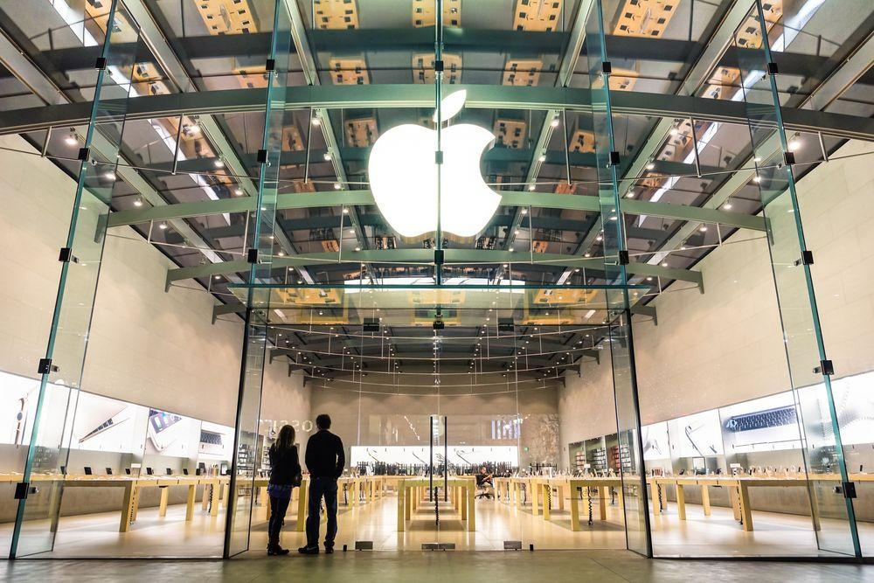
Source: View Apart/Shutterstock.com

Lessons from the Rise and Fall and Perhaps Rise Again of Threads—Meta’s Challenge to Post-Musk Twitter (Err, X)
Elon Musk's acquisition of Twitter was not going well. The site's power users were outraged that they lost the exclusive “blue checkmark.” Now anyone could get a check if they paid a $6 a month subscription fee. This was handled terribly. Scammers and trolls were creating accounts using brand names, buying a checkmark, and impersonating major organizations, cratering trust among users and potential advertisers. The site had also changed trust and safety policies, leading to an increase in online trolling. Musk himself wasn't helping—spouting a series of unpopular statements that turned off advertisers as well as a large portion of the site's user base. Celebrities and average users alike began to leave the site or use it less often, and advertisers cut Twitter spending. Musk even flipped the bird—ditching Twitter’s globally recognized branding for a black letter “X”, apparently because this is his “favorite letter.” Sensing an opportunity, Meta created a stand-alone Twitter competitor called Threads and built the app on Instagram's account system. If you had an account on Instagram, which at the time boasted over 500 million daily active users (DAUs), then you'd simply log into Threads using your Instagram credentials and boom—you were on Threads. Even better, your Instagram followers and those you were following would automatically connect via Threads when they joined, layering on an opportunity for the “exchange” benefit of network effects while removing the friction of heavy switching costs. Within five days, Threads had 100 million users, dethroning ChatGPT as the most rapidly adopted app of all time. This was especially noteworthy since Threads didn’t launch in Europe, for fear it wouldn’t comply with EU data handling regulations. The launch showed how quickly a firm can grow if it leverages one successful platform to ease adoption of another. Threads was no upstart—it was a peer moving into Twitter’s space with significant assets for competitive advantage. And while Threads launched without advertising—once Meta turns that on, the firm has robust ad sales systems and teams in place, and long-established relationships with client advertisers, many of whom have grown weary of advertising on brand-toxic X.
But getting users to download the app and log in was only one piece of the competitive puzzle. The next step is to offer a service that's better than your rival, or in the case of the Twitter diaspora—at least one that's just as good as Twitter so that users had a true replacement of the firm that had repulsed them. Unfortunately, the Threads team failed to deliver. The app was launched before it had introduced several vital features, including robust hashtags, trending terms and posts, direct messages, search, a chronological feed, or even a desktop browser version. Other users didn't necessarily want to use their Instagram handle and instead wished to use the same one they'd used on Twitter—unfortunately Threads didn't allow you to create a new account if you were an Instagram user. Users quickly soured and usage crashed. About 100 million people who created Threads’ accounts failed to come back. Those who did were Threading just 2.4 minutes a day, down more than 80 percent from Threads’ early July peak.
As of this writing, the competition between Musk and Zuck is still early. Threads has yet to add the open standard, ActivityPub, that would allow its content to appear on other sites and vice versa. This could let firms build a single app to aggregate content ranging from decentralized Mastodon to WordPress to TikTok (the services using ActivityPub are collectively referred to as the “Fediverse”). Hastags were implemented on Threads, but only one-per-post and in a way that required a highlight and click, less intuitive than simply typing # before a word. Mercurial Musk also seems to almost want to destroy X. He has made statements widely regarded as antisemitic, causing dozens of major advertisers to drop the platform. Musk later responded that advertisers could “f- themselves.” Apparently the business acumen it takes to create a car and space company doesn’t directly translate into the ability to run a social media platform. Early signs suggest that many journalists and advertisers may have had enough of X, and Threads is experiencing yet another uptick. But the Threads launch and subsequent struggle has a few interesting lessons: One is that customers are willing to abandon a site, even if there are strong network effects, if they find changes make the site less usable. Another is that Threads showed how a firm can leverage one platform to dramatically lower switching costs and remove friction to quickly grow the user base of a new platform. Finally, Threads rapid drop in usage shows that if a would-be competitor wants to take advantage of users seeking an alternative, then a genuine, full-featured alternative needs to be offered.
Twitter versus Threads Is More Interesting Than You Think
Transcript

Seed the Market
When Sony launched the PS3, it subsidized each console by selling it at a price estimated at $300 below unit cost. Subsidizing consoles is a common practice in the video game industry—game player manufacturers usually make most of their money through royalties paid by game developers. But Sony’s subsidy had an additional benefit for the firm—it helped sneak a Blu-ray player into every home buying a PS3 (Sony was backing the Blu-ray standard over the rival HD DVD effort). PS3 had struggled with fierce competition, but initially seeding the market with low-cost Blu-ray players at a time when that hardware sold at a very high price gave eventual winner Blu-ray some extra momentum. Since Sony is also a movie studio and manufacturer of DVD players and other consumer electronics, it had a particularly strong set of assets to leverage to encourage the adoption of Blu-ray over rival HD DVD.
Giving away products for half of a two-sided market is an extreme example of this kind of behavior, but it’s often used. In two-sided markets, you charge the one who will pay. Adobe gives away the Acrobat Reader to build a market for the sale of software that creates Acrobat files. In your parents’ day, firms with Yellow Page directories gave away countless copies of their products, delivered straight to your home, in order to create a market for selling advertising. Today, Google does much the same by providing free, ad-supported search.
Consignment firm ThredUp buys clothing from one group of customers, then photographs and warehouses them for resale to others. Sending high-quality used clothes to ThredUp can be a quick way to earn cash, but it can also lead to a lopsided market, where supply exceeds demand. In order to seed the “buy” side for its duds by encouraging sellers to become buyers, too, ThredUp will give clothes sellers immediate purchase credit for any resale items that ThredUp accepts for sale. Want cash instead? You’ll get it, but you’ll have to wait two weeks.

Encourage the Development of Complementary Goods
There are several ways to motivate others to create complementary goods for your network. These efforts often involve some form of developer subsidy or other free or discounted service. A firm may charge lower royalties or offer a period of royalty-free licensing. It can also offer free software development kits (SDKs), training programs, co-marketing dollars, or even startup capital to potential suppliers. Microsoft and Apple both allow developers to sell their products online through Xbox LIVE Marketplace and the App Store, respectively. This channel lowers developer expenses by eliminating costs associated with selling physical inventory in brick-and-mortar stores and can provide a free way to reach millions of potential consumers without significant promotional spending.
Firms are also leveraging several techniques to encourage the creation of complementary goods for their platforms. Oculus has a $10 million fund to encourage indie game developers to build for the platform; Slack has announced an $80 million investment fund intended to boost companies that are building products that enhance the firm’s business productivity platform; and Amazon has a $100 million fund for developers enhancing technologies and providing new apps (called “skills” by Amazon) for its voice-activated Echo products. Apple has taken encouraging developers a step further by offering Swift Playgrounds in the iPad, a kid-focused learn-to-program environment featuring the created-by-Apple Swift programming language. Apple has since open sourced Swift so it can be used on development efforts outside its own products, and its broad efforts to encourage Swift adoption have made Swift one of the world’s most popular and in-demand programming languages.

Leverage Backward Compatibility
Those firms that control a standard would also be wise to ensure that new products have backward compatibility
The ability to take advantage of complementary products developed for a prior generation of technology.
with earlier offerings. If not, they reenter a market at installed-base zero and give up a major source of advantage—the switching costs built up by prior customers. For example, when Nintendo introduced its sixteen-bit Super Nintendo system, it was incompatible with the firm’s highly successful prior-generation eight-bit model. Rival Sega, which had entered the sixteen-bit market two years prior to Nintendo, had already built up a large library of sixteen-bit games for its system. Nintendo entered with only its debut titles and no ability to play games owned by customers of its previous system, so there was little incentive for existing Nintendo fans to stick with the firm. iTunes users also found migration to Spotify particularly easy since the latter offered the option of importing Apple playlists.
Backward compatibility was vital to Apple's strategy to move Mac users and developers from the Intel processor to its new, home-grown, faster, and more energy efficient M1 chip. Intel chips aren’t compatible with the instruction set used by the new M1 chips, which were based on technology licensed from ARM, then heavily modified. Think of this as two entirely different languages—Intel speaks French, Apple’s MXCHIPs speak Urdu. To ease the transition, Apple included a free software-based adaptor
A product that allows a firm to tap into the complementary products, data, or user base of another product or service.
, called Rosetta 2, that automatically emulated the functionality of the Intel on all new MX Macs (a sort of French-to-Urdu translator). By doing so, all new Macs with “Apple Silicon” could use the base of existing software written for the old Intel chip; owners of Intel Macs were able to upgrade while preserving their investment in old software; and software firms could still sell older programs while they rewrote applications for new Apple Silicon. The transition from Intel to Apple Silicon wasn’t just effortless for most customers; the superior chip actually allowed Apple to gain market share, moving from 12.4 percent of the PC market in Q3 2020 (when the M1 chip was introduced) to 17.2 percent of the market by Q4 2022.
Samsung also leveraged backward compatibility to make Samsung Pay accepted at more retailers than either Apple Pay or Google Pay. Samsung Pay uses a technology called magnetic secure transmission (MST), which emits a magnetic signal that simulates the magnetic strip found on the back of a credit or debit card. Since vendor point-of-sale (POS) systems see Samsung Pay as if it were a regular credit card, merchants don’t even need to agree to accept Samsung, it just works like plastic. A small subset of POS systems, like gas station pumps and ATMs, still require physically inserting a card, but the vast majority of merchant terminals accept the Samsung MST signal. Samsung Pay is still limited because it only works with certain phones, bank cards, and carriers, but its broad acceptance removes a major barrier to customer acceptance.

Rivals: Be Compatible with the Leading Network
Companies will want to consider making new products compatible with the leading standard. Microsoft’s Live Maps and Virtual Earth 3D arrived late to the Internet mapping game. Users had already put in countless hours building resources that meshed with Google Maps and Google Earth. But by adopting the same keyhole markup language (KML) standard used by Google, Microsoft could, as TechCrunch put it, “drink from Google’s milkshake.” Any work done by users for Google in KML could be used by Microsoft. Voilà, an instant base of add-on content!

Incumbents: Close Off Rival Access and Constantly Innovate
Oftentimes, firms that control dominant networks will make compatibility difficult for rivals who try to connect with their systems. For example, while many firms offer video conferencing and Internet calling, the clear leader is Skype, a product that for years had been closed to unauthorized Skype clients.
Firms that constantly innovate make it particularly difficult for competitors to become compatible. Again, we can look to Apple as an example of these concepts in action. While Macs can run Windows, Windows computers can’t run Mac programs. Apple has embedded key software in Mac hardware, making it difficult for rivals to write a software emulator like Boot Camp that would let Windows PCs drink from the Mac milkshake. And if any firm gets close to cloning Mac hardware, Apple sues. The firm also modifies software on other products like the iPhone and iTunes each time wily hackers tap into closed aspects of its systems. And Apple has regularly moved to block competing third-party hardware products from plugging into iTunes. Even if firms create adaptors that emulate a standard, a firm that constantly innovates creates a moving target that’s tough for others to keep up with.
Apple has been far more aggressive than Microsoft in introducing new versions of its software. Since the firm never stays still, would-be cloners never get enough time to create a reliable emulator that runs the latest Apple software.

Large, Well-Known Followers: Preannouncements
Large firms that find new markets attractive but don’t yet have products ready for delivery might preannounce efforts to cause potential adaptors to sit on the fence, delaying a purchasing decision until the new effort rolls out. Preannouncements only work if a firm is large enough to pose a credible threat to current market participants. While Apple rarely preannounces products, it previewed Apple Watch roughly eight months before it was ready to ship. Rivals from the Kickstarter darling, Pebble, to Google’s Watch were courting developers, but Apple’s early product demonstration caused many customers considering wearables to hold off until Apple Watch was out. Developers also knew that, unlike fragmented Android Wear offerings with varying watch face shapes and capabilities, Apple Watch would provide a uniform standard offered by the industry’s biggest player. Apple’s announcement of VisionPro months before the product ships is a repeat of this page of the playbook, and will no doubt cause many developers and customers to think twice before investing in products from Meta or other rivals. While large, respected firms may be able to influence markets through preannouncements, startups often lack credibility to delay user purchases. The tech industry acronym for the impact firms try to impart on markets through preannouncements is FUD, for fear, uncertainty, and doubt.

The Osborne Effect
Preannouncers, beware. Announce an effort too early and a firm may fall victim to what’s known as “The Osborne Effect
When a firm preannounces a forthcoming product or service and experiences a sharp and detrimental drop in sales of current offerings as users wait for the new item.
.” It’s been suggested that portable computer manufacturer Osborne Computer announced new models too early. Customers opted to wait for the new models, so sales of the firm’s current offerings plummeted. While evidence suggests that Osborne’s decline had more to do with rivals offering better products, the negative impact of preannouncements has hurt a host of other firms. Among these, Sega, which exited the video game console market entirely after preannouncements of a next-generation system killed enthusiasm for its Saturn console.

Too Much of a Good Thing?
When network effects are present, more users attract more users. That’s a good thing as long as a firm can earn money from this virtuous cycle. But sometimes a network effect attracts too many users, and a service can be so overwhelmed that it becomes unusable. These so-called congestion effects
When increasing numbers of users lower the value of a product or service.
occur when increasing numbers of users lower the value of a product or service. This most often happens when a key resource becomes increasingly scarce. Fortune reported how the launch of a new version of the hit EA game SimCity fell victim to congestion effects, stating that “thanks to what the company called ‘overwhelming demand,’ players experienced a myriad of problems like failures to load the game entirely and wait times of twenty minutes to log in. Game play became so problematic that Amazon temporarily halted sales of the game, and EA offered users the option of downloading a free game from its online store.” Twitter’s early infrastructure was often unable to handle the demands of a service in hypergrowth (leading to the frequent appearance of a not-in-service graphic known in the Twitter community as the “fail whale”). Social media users with a large number of friends may also find their attention is a limited resource, as feeds push so much content that it becomes difficult to separate interesting information from the noise of friend actions.
And while network effects can attract positive complementary products, a dominant standard may also be the first place where virus writers and malicious hackers choose to strike.
Feel confident! Now you’ve got a solid grounding in network effects, the key resource leveraged by some of the most dominant firms in technology. And these concepts apply beyond the realm of tech, too. Network effects can explain phenomena ranging from why some stock markets are more popular than others to why English is so widely spoken, even among groups of nonnative speakers. On top of that, the strategies explored in the last half of the chapter show how to use these principles to sniff out, create, and protect this key strategic asset. Go forth, tech pioneer—opportunity awaits!

Key Takeaways
- Moving early matters in network markets—firms that move early can often use that time to establish a lead in users, switching costs, and complementary products that can be difficult for rivals to match.
- Additional factors that can help a firm establish a network effects lead include subsidizing adoption; leveraging viral marketing; creating alliances to promote a product or to increase a service’s user base; redefining the market to appeal to more users; leveraging unique distribution channels to reach new customers; seeding the market with complements; encouraging the development of complements; and maintaining backward compatibility.
- Established firms may try to make it difficult for rivals to gain compatibility with their users, standards, or product complements. Large firms may also create uncertainty among those considering adoption of a rival by preannouncing competing products.

10.6 The Apple Platform Cashes In on Banking

Learning Objectives
- Learn how Apple and rivals are getting into consumer banking services.
- Understand how some rivals are responding, which strategies they are using, which efforts had been tried previously, failed, and why.
JP Morgan Chase is one of the largest, most powerful financial institutions on the planet, but when asked about the threat posed by new financial technologies (fintech) JP Morgan Chase head Jamie Dimon didn’t miss a beat with his concern: “We should be scared sh*tless about that!” One firm on the mind of nearly everyone in the consumer banking space is Apple, but Google, Amazon, and anyone else with a digital tether to banking customers is elbowing their way into their consumer business.
When you buy using a credit card, the store that you buy from pays a small fee to the bank issuing your card—this is about one to three percent for most U.S. credit cards. When Apple launched Apple Wallet, it gained an unprecedented concession from banks, who agreed to pay Apple 0.15 percent of every credit card transaction facilitated by Apple Pay. That may sound like a minuscule amount, but it adds up. Apple took in $782 million from Apple Pay in 2022. In 2019, Apple went beyond payment facilitator to become a branded credit-card issuer—launching the Apple Card Credit Card in direct competition with credit card–issuing banks. And this wasn't a simple vanity card with an Apple logo attached. Apple Card offered 3 percent cash back on Apple purchases and 2 percent cash back when used with Apple Pay. The card had no late fees, no annual fees, no international fees, and no over-limit fees. The physical card issued has only the Apple logo on the front (the Goldman and MasterCard logo are on the back), and Goldman's name doesn't appear at all throughout the digital experience, which most Apple users are most likely to use despite the cool factor of the alabaster titanium card. In 2023, Apple got even further into consumer banking with the launch of its Apple buy-now-pay-later (BNPL) program. Neither Goldman nor any other bank was involved in Apple BNPL—these short-term loans are handled entirely by an Apple-owned subsidiary, Apple Financing LLC. Apple did partner again with Goldman when it introduced the very competitive Apple Savings Account a few months later. Apple Card holders could put money into the savings account, one with no minimum deposits, no minimum balances, and no fees, and that most notably launched with a 4.15 percent rate, which was about ten times more than the average for conventional bank savings accounts at the time of launch. Goldman has been losing hundreds of millions through what the firm admits was “poor execution,” and the Apple-Goldman relationship might come to an end. But even if Goldman gets cold feet, it's Apple's brand front-and-center with these consumer banking experiences, and Apple should be able to find a new partner or eventually bring these functions in-house.
Banks are scared, and slow. In an event to counteract the increasingly ubiquitous Apple Pay button you're seeing on websites and inside apps, seven major banks have banded together to form a rival service called Paze (pronounced Payz). Forming an alliance of large users can be an effective strategy for creating a standard, but banks are late to the game. The seven U.S. banks that jointly own Paze—Bank of America, CapitalOne, Chase, PNC, Truist, US Bank, and Wells Fargo—need to convince websites and apps to grant them screen real estate along with not only the Apple Pay button, but also other tech-savvy rivals that include Google Pay, PayPal, and Amazon Pay.
This isn't the first time firms have tried to band together to craft a digital payments rival. A consortia of big-name retailers that included Walmart, Target, Wendys, and Dunkin backed an effort named MCX and its payment scheme CurrentC (get it). CurrentC never caught on, and Chase bought the assets and tried its own payment app, ChasePay, but shuttered this effort as well. Both efforts failed to offer a compelling reason for consumers to try something new when a working, trusted solution was already in place. CurrentC failed to even use some of the basic platform accelerators, like subsidizing early adopter purchase. Paze will be run by the existing bank-owned firm “Early Warning Services,” the entity responsible for the banks’ Venmo and CashApp rival, Zelle. While Zelle does claim impressive numbers, it’s not exactly the brand folks first think of when sending cash. With Paze, key questions include what's the benefit for consumers, and did banks show up too late? Apple's growing presence in banking isn't a slam dunk, either, especially with anti-trust concerns growing around the globe. Regulators will wonder if Apple's double-press of the iPhone side button to launch Apple Pay doesn't constitute favored access that has shut out competition. And what about Apple’s access to sending cash over its Messaging platform? If this is seen as anti-competitive, this could impact Apple's banking ambitions.
Apple versus Banks: The Digital-Wallet War, Explained
The Wall Street Journal provides an overview of Apple’s move into consumer banking services, and bank efforts to create a rival platform with Paze.

Key Takeaways
- Apple has aggressively moved into fintech services. Apple Pay earns a small percentage of each transaction, paid by banks who issue credit cards used in payment. This generated over $782 million for the firm in 2022.
- Apple has introduced a credit card and a savings account, both with the help of Goldman Sachs, a large financial institution, but one that did not have a strong presence in consumer banking prior to working with Apple. Apple’s credit card and savings accounts offer a number of benefits that are more competitive than most standard bank offerings.
- Apple has created its own subsidiary to handle short-term loans for its buy-now-pay-later (BNPL) offering.
- Rivals are forming a consortium to create a rival to Apple Pay, and similar consumer fintech payment efforts (e.g., Google Pay, PayPal, Amazon Pay). However, past efforts have failed to offer compelling reasons for consumers to try something new when they were satisfied with an existing effort.
- Apple devices—including the iPhone and Apple Watch—present a powerful distribution channel for the firm’s fintech services; however, regulators are increasingly evaluating whether these sorts of distribution channels provide an unfair advantage by allowing a company to favor its own offerings over rival efforts.

10.7 The Zoom Boom—Big Guys Can Be Beat

Learning Objectives
- Recognize how Eric Yuan’s departure from WebEx follows a pattern similar to that of other leaders who have created successful disruptive firms.
- Understand how Zoom used a superior product, a freemium offering, simplified pricing, and appeal to a larger addressable market to capture the COVID-19-fueled segment for online meetings, despite facing larger, established competitors.
Before the pandemic, almost no one, including this author, would have said the firm Zoom would become a household name and would lead the business of video meetings. The biggest name in video calling was Cisco's WebEx group on the corporate side—a company that dominated networking hardware and had for years been selling professional video conferencing solutions as part of other offerings. Other established rivals included GoToMeeting, Microsoft Teams, and Google Hangouts Meet. On the consumer side, Microsoft's Skype, Google, Facebook, WhatsApp, and Apple FaceTime were also choices many would reach for instead of the relatively unheard of Zoom.
The company's rise defies logic—how could a lesser known firm with fewer competitive assets win this race when facing so many firms that had a similar product in place? To be clear—first and foremost, Eric Yuan, a Chinese immigrant to the United States who founded Zoom, was in the right place at the right time. But Yuan also had a long-standing vision that positioned him perfectly to win. True of many disruptive innovators, Yuan worked for the biggest player in the space. He helped build an early version of WebEx and, after the firm was acquired by Cisco, rose to become VP of engineering. In his role at Cisco, Yuan regularly met with customers and felt pain and embarrassment when these meetings ended with repeated complaints and dissatisfaction. WebEx was difficult to install, especially across platforms, customers complained of dropped calls, and jerky, lagging video quality. When Yuan repeatedly brought ideas to Cisco brass for improvements that would placate existing customers and expand the customer base, he was rebuffed. WebEx was relatively comfortable with its current market share and Cisco's real contributions to earnings came from networking hardware, not video conferencing browser extensions. Eventually Yuan's frustration stewarding a product that he knew could be better led him to quit Cisco, and to take forty engineers with him, to found Zoom.
A bad product with grumpy customers creates an opportunity, and Yuan set to focus his new firm on addressing complaints against WebEx. Zoom would be easy to install across platforms, and equally easy to use. Call reliability would be improved. Yuan's team had a laser-like obsession on limiting any video lag to below 150 milliseconds (the point at which humans perceive problems in a video call). Any offering would be feature rich so customers could see Zoom's advantages, and pricing would be super simple to understand. When setting up Zoom, the product immediately recognizes a customer's platform and selects the right software to install behind the scenes, no more “Mac users click here, Windows click over here, use this link if you have a different browser,” etc. If you had a browser, you could be Zooming in seconds. Smartphone and tablet users had a similar, full-featured, easy-to-install app experience. Zoom meeting codes were based on digits—Skype, by contrast, required a more complex upper- and lower-case alphanumeric key that was easy to mis-type. Even more significantly, all you needed to hop into a Zoom meeting was the code—there was no burdensome initial account setup (this openness also created problems, detailed below). Since Zoom was a low-friction choice, many users who sought to start an online meeting or broadcast without burdening viewers with a signup chose Zoom—fueling viral promotion of the software. Customers installing Zoom got all of the features in the free version that they'd get from the paid product—the only difference was that free Zoom meetings expired in forty minutes, and were limited to 100 users. This particular implementation of the so-called “freemium
A product with a free version—sometimes with limited features or that stops working after a period of time—to allow customers to try a product and hopefully entice them into making a product purchase or subscription decision.
” model removed guesswork involved in upgrading, so signup for the low price of $9.99 was an easy decision to make. And Zoom's ease-of-use but feature-rich offering occupied that rare space that appealed to professional corporate customers as well as to consumers looking to Zoom with grandma or set up playdates for their kids.
Zoom launched its first product in 2013 and grew quickly. It claimed 1 million users in its first five months, 10 million by the next year. The company grew steadily over the next few years and raised over $100 million across several investment rounds. Zoom went public in March 2019, raising over $350 million more to fuel additional expansion. Zoom had prepared exquisitely and was growing steadily, but no one foresaw the intensity of market demand that would arise from COVID-19.
When the abrupt global shutdown caught organizations off guard worldwide, IT departments scrambled for an easy solution. No support person wants to be screamed at that a provided solution didn't work, was too complex to install, or was laggy. Low-cost (free at first) Zoom emerged as best-in-class and also for many, one of the cheapest—even among firms that were already using WebEx or other solutions. Desperate, overworked IT staff migrated to the clearly superior version. Early adoption from low-tech school districts also helped. Parents learned how to Zoom when their kids' schooling went remote and Yuan, savvily, gave Zoom away free to K–12 schools. This was a risky move—the firm was already overtaxed, and giving the professional-tier product away like this was akin to subsidizing (in effect offering a product for free to a segment of the market) when it would inevitably lead to support costs and taxing of the firm’s infrastructure. But the move turned out to be a brilliant stroke in fueling awareness and eventually network effects. When corporate solutions caused problems, employees requested Zoom—the better product that many became familiar with through their children. Newscasts and other media began to use Zoom, mentions rose, and within weeks it was clear that we were “Zooming” during the pandemic, not WebEx-ing, FaceTime-ing, Skype-ing, or using Google Hangouts, WhatsApp, or any other rival service for our video meetings. People began to use Zoom because everyone else was using Zoom. Zoom's network effects curve grew like a hockey stick almost overnight. Yuan's vision had won.
It wasn't an easy victory. Zoom’s user base increased twenty-fold in just four months. Early security gaffes, privacy problems, and the rise of unforeseen issues like Zoom bombing—where video creeps would crash meetings with offensive actions and other disruption—were being reported over the media, and no one wants software used by schoolkids to be vulnerable to a masked freak who sneaks in and exposes themselves. But Zoom already had experience in triaging security issues. Before the pandemic, the company scrambled to overcome a temporary ban imposed by Apple when Zoom software, even when removed from Macs, created a security vulnerability. A culture of rapid response had been nurtured even as Zoom grew into a public company, and this served the firm well through multiple crises in the COVID-19-growth period. When a barrage of unforeseen security and privacy issues hit, Yuan halted the release of any new features for ninety days so all engineers could work on stamping out issues. Marketing teams were refocused on helping educate customers when simple settings could make Zoom more secure, and some of the product's open settings were turned off by default. In September 2020, when Zoom posted earnings that surpassed the expectations of even the most hyper-bullish Wall Street analysts, the company's market cap shot up over $37 billion—adding over half the value of Verizon in a single day.
A run-up in a time of crisis doesn't guarantee future success, and a nosebleed stock valuation can often be a curse. The arrival of vaccines and the return to office work and in-person schooling meant there were a lot fewer video meetings than during the Zoom boom. As a result, revenue went from 300 percent growth for three quarters in 2021 to just 4.6 percent in 2022. Like many firms that staffed up due to pandemic growth, Zoom was forced to lay off 1,300 employees in early 2023 and, taking responsibility for mismanaged expectations, the CEO cut his own annual pay to just $10,000. Just one quarter later, Zoom was already adjusting sales and profit expectations higher for the coming year. But the rise of Zoom provides a host of key lessons for business students. First, we see how Cisco and others lost a market that was an afterthought by failing to focus on customer needs. This created an initial opportunity that former WebEx employees felt so passionate about that they left their jobs to start a better company. Zoom's ease-of-use positioned it in the rarely occupied professional/consumer (sometimes called “prosumer”) space with a very wide target market that spanned corporate and casual use. The freemium model was structured to expose nearly every feature available to subscribers, and pricing was cheap and straightforward, making the move from free tier to paid subscriber an easy decision. And the firm's commitment to rapid response, maintaining a startup's nimbleness when growth as a public company often introduces slower speeds and internal bureaucracy, was vital for dealing with unseen circumstances. Market leader, beware: Like Yahoo!, which led early in search, Friendster in social networking, and WebEx in web meetings, if you take your eye off the demands of the market long enough for a better product to come to market and use lead time to build network effects, switching costs, brand, and other sustainable sources of competitive advantage, you could miss out on a golden opportunity. Take it from Yuan—a founder whose surname, when written in English, reads like the name of China's currency.
How Zoom Beat Skype and Won Against the Competition
This video raises some key points and provides background on Eric Yuan’s early moves that positioned Zoom for dominance in the COVID-19 era.
Transcript

Key Takeaways
- Eric Yuan, who helped build WebEx and was Cisco’s WebEx VP of engineering, repeatedly heard, firsthand, of customer disappointment in the firm’s product. Yuan’s attempts to refocus Cisco on addressing customer dissatisfaction and growing the market led Yuan to leave Cisco and start Zoom, taking forty engineers with him.
- Zoom wasn’t an overnight success. It was started in 2013, but had received praise from users for its high-quality, easy-to-use, and feature-rich offering.
- A freemium pricing model that offered all features and 100 simultaneous users with just a forty-minute limitation, spurred Zoom experimentation. Using Zoom required a code, not a signup, so this low-friction product adoption fueled virality among users who wanted to start a meeting without losing anyone in a cumbersome signup process.
- Offering Zoom free to K–12 customers in the pandemic was a risky move and the subsidy led to lots of work and expense for the firm with no direct revenue. Zoom saw its customer base explode by twenty times in just four months. But parents familiar with Zoom who were also in IT or who communicated dissatisfaction with rival platforms to their IT staff, helped fuel Zoom demand.
- Cisco and others had not focused on need and opportunity in the market. Zoom was positioned for the unique COVID-19-created chance to grow market, seemingly overnight, by offering a superior product when it was desperately needed.
- Even though the company faced many security, privacy, and outage issues, it maintained a nimble ability to respond quickly to challenges. The CEO also refocused staff on addressing challenges, pausing new features for ninety days, allowing the firm to address the most pressing security, privacy, and scaling issues that were raised during Zoom’s period of intense growth.

